National University of Computer and Emerging Sciences



Lab Manual # 09
Digital Logic Design
(EL1005)

Course Instructor | Mr. Haris Jamil
Lab Instructor(s) | Mr. Haris Jamil  Mr. Salman Mubarak
Section | BCS-2H
Semester | Spring 2022

Department of Computer Science
FAST-NU, Lahore, Pakistan
Objectives:
Understanding of Flip Flops
- SR Flip Flops
- D Flip Flops
- JK Flip Flops

SR Flip Flops:

SR flip flop IC is not available in Lab so implement it by Combinational Circuit.
Circuit diagram + Truth Table:
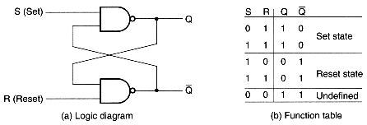
Timing Diagram:
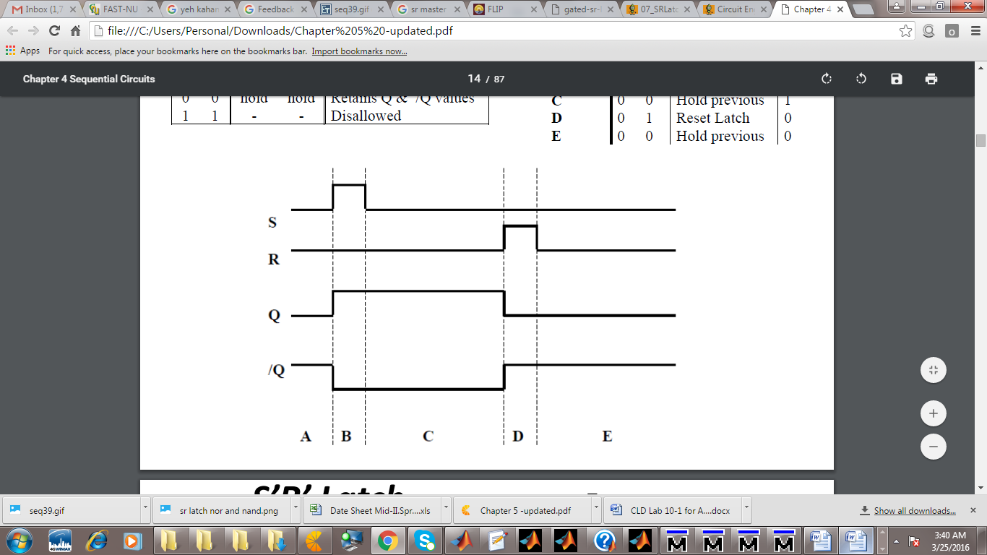

D Flip Flops:

IC code 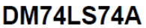
IC configuration:

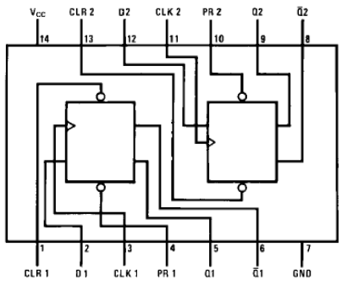
Truth Table:
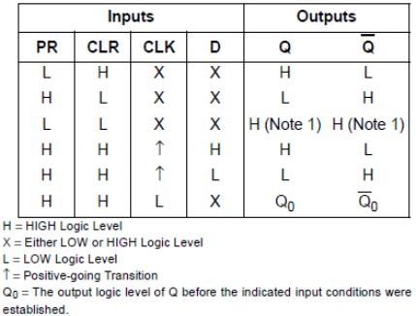

JK Flip Flops:

IC code DM74LS76A
IC configuration:
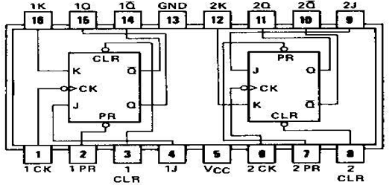
Truth Table:
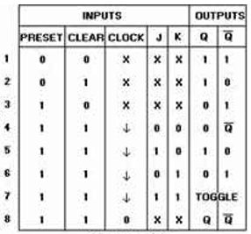
Lab Tasks

Question 1: (6+4+5+5)
Implement the work on +ve edge trigger
- Circuit on Logic Work
- Circuit on Logic Trainer
- Truth Table
- Timing Diagram

Question 2: (6+4+5+5)
Implement the JKflip flop by using D flip flop work on +ve edge trigger
- Circuit on Logic Work
- Circuit on Logic Trainer
- Truth Table
- Timing Diagram

